Business Model Documentation

Topic: StackIT – A Developer-Centric Q&A Platform
Name: Princi Shah
Date: 14th July, 2025

1. Objective
StackIt is a modern, minimal, and developer-focused Q&A platform tailored specifically for coding-related questions. It is designed to empower learners, students, and professional developers to share knowledge in a respectful, structured, and beginner-friendly environment.
- Simplify the Q&A process for coding-related queries.
- Foster a supportive and inclusive community.
- Offer AI-driven assistance and moderation.
- Build an ecosystem of mentorship, gamification, and developer-focused resources.

2. Master Data

User Categories
- Students: Computer Science & Engineering students, bootcamp attendees
- Self-Taught Programmers: Independent learners seeking community support
- Junior Developers: Early-career professionals requiring guidance
- Senior Developers: Experienced professionals sharing knowledge
- Educators & Mentors: Teaching professionals and industry experts
- Institutions: Colleges, bootcamps, and educational organizations
- Companies: Tech companies seeking talent and promotion opportunities

Content Data Structure
- Questions: Title, description, code snippets, tags, difficulty level
- Answers: Content, code examples, explanations, validation status
- Tags: Programming languages, frameworks, concepts, difficulty levels
- Users: Profiles, skill levels, badges, reputation scores
- Resources: Tutorials, documentation links, learning materials

Platform Assets
- Knowledge Base: Accumulated Q&A content, tutorials, resources
- User Profiles: Reputation, badges, activity history, preferences
- Mentorship Networks: Expert-learner connections and session records
- Analytics Data: Usage patterns, engagement metrics, learning progress

3. Business Function

Knowledge Exchange
- Question Posting: Users submit coding queries with structured formatting
- Answer Provision: Community members provide solutions and explanations
- Content Curation: AI and human moderation ensure quality and relevance
- Search & Discovery: Advanced search with tag-based categorization
- Community Management
- User Onboarding: Role-based registration and profile setup
- Reputation System: Point-based recognition for contributions
- Gamification: XP, badges, streaks, and achievement tracking
- Moderation: Automated and human content review processes

Learning Enhancement
- AI Assistance: Question improvement suggestions and automated responses
- Mentorship Matching: Connect learners with appropriate mentors
- Live Sessions: Interactive workshops and Q&A sessions
- Resource Curation: Curated learning materials and tutorials

Business Operations
- Subscription Management: Premium feature access and billing
- Partnership Management: Institutional relationships and B2B services
- Job Board Operations: Employer-developer matching services
- Analytics & Reporting: Performance tracking and insights generation

Supporting Functions
- Technical Infrastructure: Platform maintenance, security, and scalability
- Customer Support: User assistance and issue resolution
- Marketing & Growth: User acquisition and retention strategies
- Financial Management: Revenue tracking and cost optimization

4. Roles and Responsibilities

Admin Role
Responsibilities:
      - Platform governance and policy enforcement
      - Moderator management and role assignments
      - Sponsored content oversight and approval
      - Escalation handling and dispute resolution
      - System-wide analytics and performance monitoring
Business Impact:
      - Ensures platform integrity and user trust
      - Manages revenue-generating partnerships
      - Maintains quality standards across all content

Moderator Role
Responsibilities:
      - Content review and flagged post resolution
      - User behavior monitoring and enforcement actions
      - Community guideline implementation
      - Quality assurance for questions and answers
      - Dispute mediation between users
Business Impact:
      - Maintains community standards and user experience
      - Reduces administrative burden on admins
      - Ensures content quality and platform reputation

Mentor Role
Responsibilities:
      - Provide expert-level answers and guidance
      - Conduct live sessions and workshops
      - Approve and validate learning resources
      - Participate in mentorship matching programs
      - Review and improve beginner-friendly content
Business Impact:
      - Drives premium subscription value
      - Attracts and retains users seeking expert guidance
      - Generates revenue through specialized services

Developer/User Role
Responsibilities:
      - Ask well-formatted coding questions
      - Provide helpful answers to community queries
      - Participate in voting and content curation
      - Follow community guidelines and etiquette
      - Report inappropriate content and behavior
Business Impact:
      - Creates core platform content and value
      - Drives user engagement and retention
      - Provides foundation for monetization strategies

Premium User Role
Responsibilities:
      - Access exclusive features and content
      - Participate in closed mentorship sessions
      - Provide feedback on premium services
      - Contribute to platform improvement through usage data
Business Impact:
      - Generates direct subscription revenue
      - Validates premium feature value proposition
      - Provides insights for service enhancement

Institutional Partner Role
Responsibilities:
      - Integrate platform with educational programs
      - Provide bulk user access and management
      - Share educational resources and curricula
      - Participate in platform development feedback
Business Impact:
      - Creates stable B2B revenue streams
      - Enables platform scaling and adoption

5. Transactional Flow

User Registration
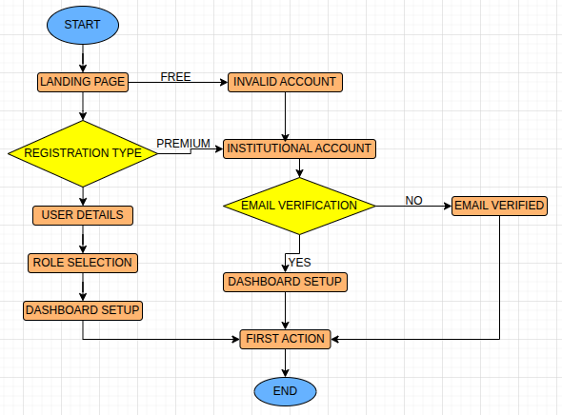

Question Posting

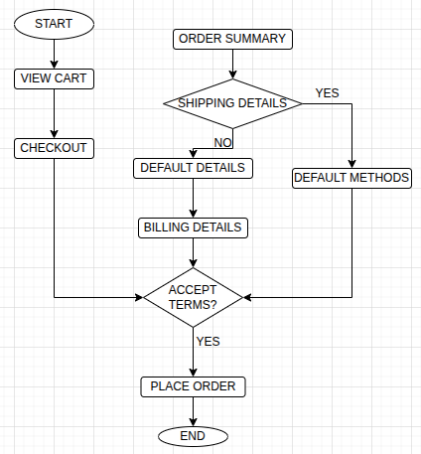

Answer Provision

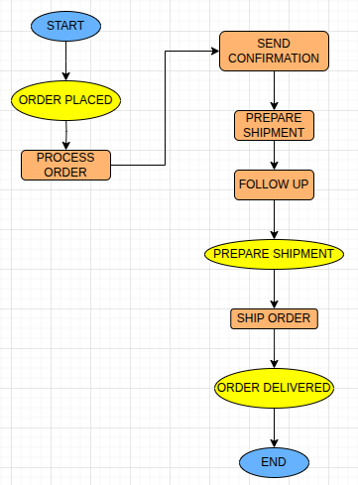

Job Board Transactions

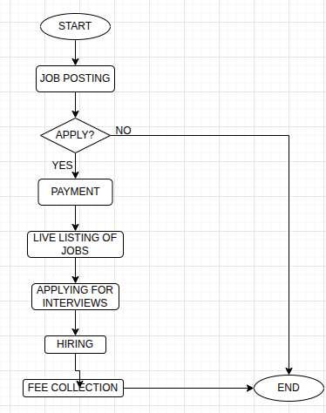

6. Business Model

1 Freemium Model
- Free for basic question-asking and answering.
- Premium for:
  - Faster expert answers.
  - Resume review and feedback.
  - Ad-free experience.
  - Access to exclusive coding tutorials.

2 B2B Partnerships
- Institutions (colleges, bootcamps) can subscribe to dashboards and analytics.
- Offer branded pages for partner organizations.

3 Sponsored Content
- Tech companies can promote courses, webinars, tools.

4 Job Board
- Charge for premium developer job postings.
- Earn referral fees from hiring partners.

7. Future Scope
- AI Tutor: Personalized coding assistant
- Resume Analyzer and Project Feedback tools
- Mobile App for on-the-go Q&A
- Coding Contests & Hackathons

8. Conclusion
StackIt envisions a future where developers of all skill levels can grow in a safe, empowering environment. With strong community engagement, AI-powered tooling, and sustainable monetization models, StackIt aims to become the go-to hub for coding-related learning and collaboration.

